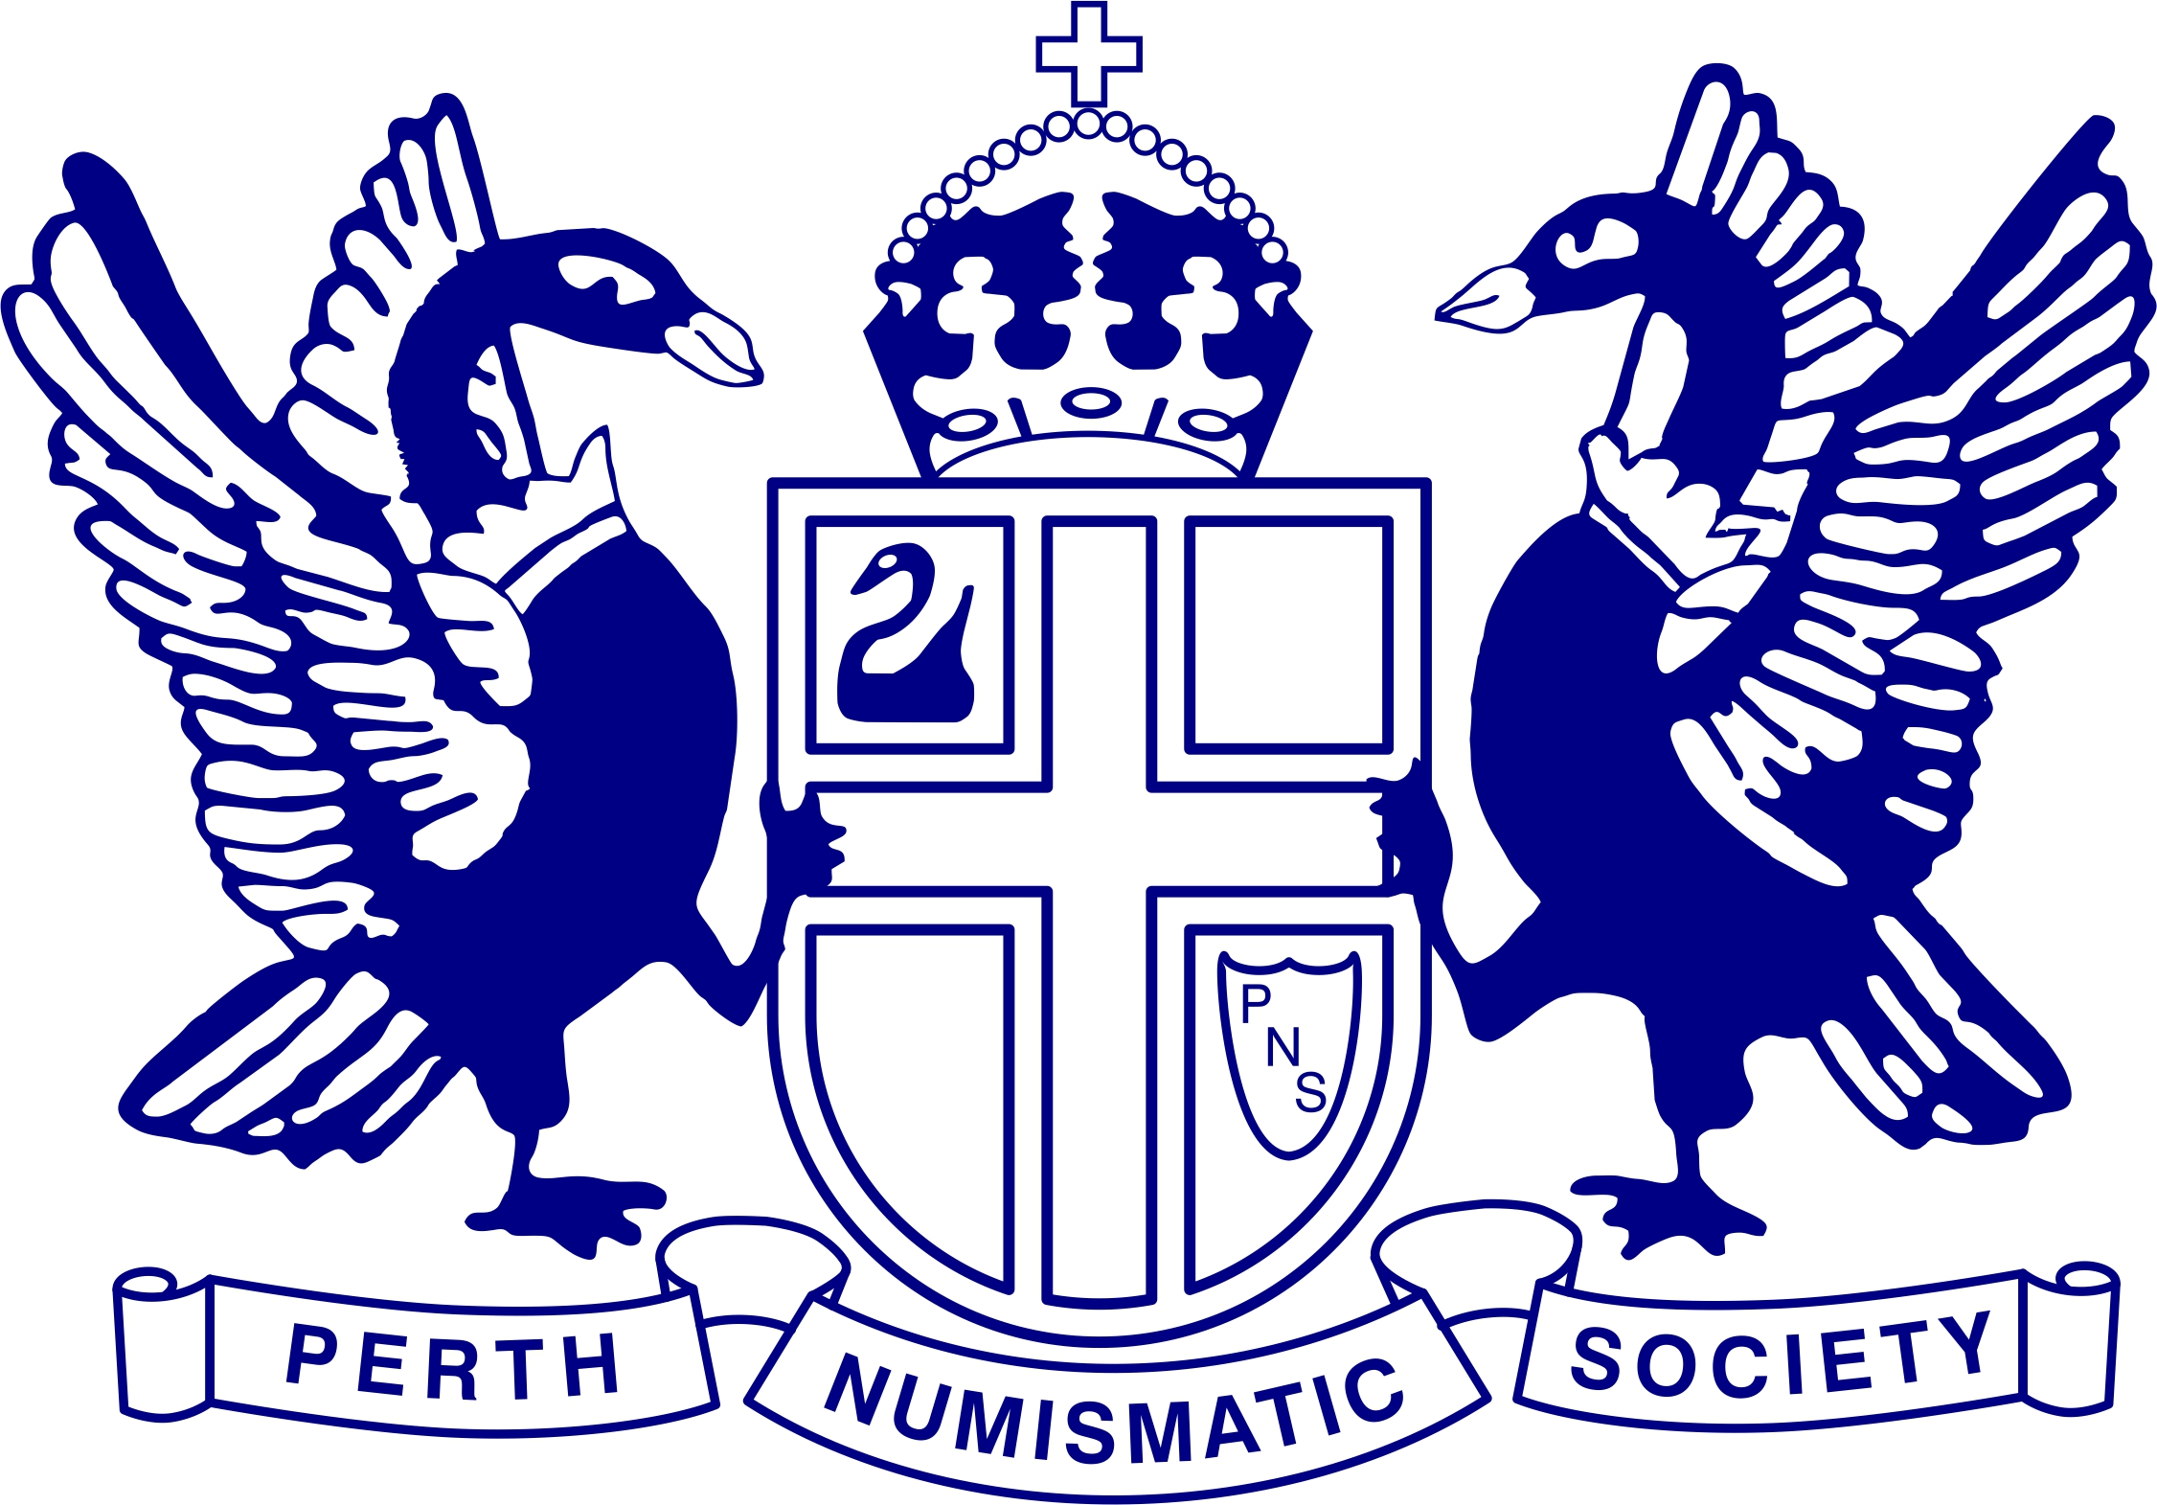

The Society was formed in March 1965 when the old £ s d coinage was about to be withdrawn from circulation, to be replaced by decimal coinage. At the time, members were interested almost exclusively in Australian coins.

Since then, there has been a substantial widening of interests as members have realised the breadth of historic, geographic and biographic studies that are made possible by world numismatics. Members collect and study world coins, banknotes, medallions and related items. Further details can be found at www.pns.org.au

The Society’s aims include:
- Helping members to collect and study numismatic items.
- Producing newsletters and journals.
- Staging lectures and exhibitions.
Meetings are held at 7:30pm, on the last Wednesday of each month (except December) at:
John McGrath Hall
97 Hensman St,
SOUTH PERTH
There is plenty of off-street parking available directly in front of the Hall. Visitors are welcome to attend.

If you are interested in becoming a Society member, please complete the form below and post it to the Secretary.
……………………………………………………………………………….…………………………….
To: The Secretary ANNUAL FEES
Perth Numismatic Society (Inc.) Adult $25
PO Box 259 Pensioner $20
FREMANTLE WA 6959 WA Country $20
Associate $10
Student $10
Nomination Fee $10
NAME: …………………………………...
My numismatic interests
ADDRESS: ……………………………… . include:

……………………………………………. ………..…………….…………….….

EMAIL: …………………………………… ………..……………….……….…….

TELEPHONE: …………………………………. ………..……………….……….…….

SIGNATURE …………………………. DATE …………………………

